Guest Post - The One Mistake Every BJJ White Belt Makes & How to Avoid It?

Meta Description

The common mistake that white belts make is focusing on the quantity, such as the number of wins, rather than the quality, which can be the ways in which you win.

Featured Image

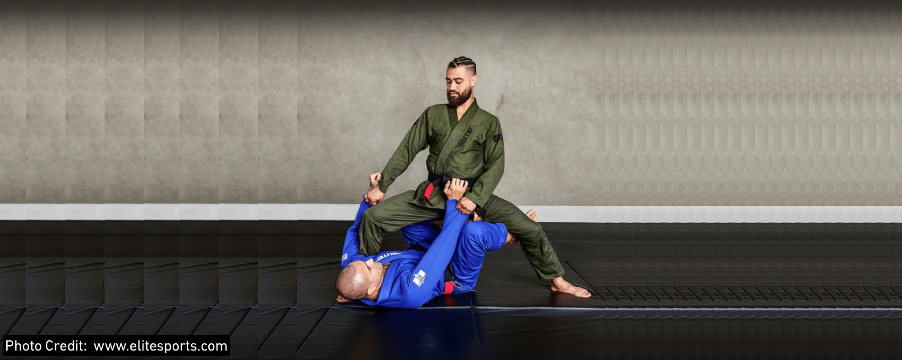

Table of Contents

30 Second Summary - Most Common Mistake of BJJ White Belt and Its Solution
1. Almost 90% of Jiu Jitsu White Belts Quit Before they Got Their Blue Belt
2. How Can You Avoid the Mistakes of Being a Jiu Jitsu White Belt?
2.1 Building Tangible Skills
2.2 Learn What You Should Do Next
2.3 Better Focus
2.4 Learn “How to”, not “What is”
2.5 Review Your Grappling and Get it Reviewed
3. Takeaway

30 Second Summary - Most Common Mistake of BJJ White Belt and Its Solution

The most common mistake that white belts make at the start of their BJJ journey is their wrong approach to training. This approach obviously develops due to getting into the wrong gyms. They try to focus on the quantity, such as the number of wins, rather than the quality, which can be the ways in which you win. You need to avoid these mistakes by having a premium quality BJJ Gi, which is very important; building tangible skills; learning what you should do next; focusing better; learning “how to,” not “what is”; and reviewing your grappling and getting it reviewed.

1. Almost 90% of Jiu Jitsu White Belts Quit Before they Got Their Blue Belt

The least motivation is found among the Jiu Jitsu white belts, and the majority of them quit before they get the promotion to the next BJJ belt. There are many reasons for that, but the number one reason is that they have to wait for almost two years to reach the blue belt. Some white belts, when they get promoted, feel they do not deserve it.

The standard Jiu Jitsu method focuses on the quantity rather than the quality when deciding your promotion. For example, it includes:

- The total number of your training sessions (classes).
- How many times have you won the match?
- How many submissions have you gotten in a session?

On the other hand, the quality of your Jiu Jitsu training includes:

- To what extent are you grasping the BJJ concepts?
- How well do you understand the moves and techniques?
- The ways you are using to win the match.
- You are not winning by getting injuries or by accidents. You are winning solely because of your skills.

This is the mistake most grapplers make when they are at the start of their Jiu Jitsu career. Let’s discover how to avoid this mistake as a white belt.

2. How Can You Avoid the Mistakes of Being a Jiu Jitsu White Belt?
The following are the ways to avoid the common white belt mistakes:

2.1 Wear a Proper Jiu Jitsu Gi

The first and foremost step in BJJ is to wear a nice and proper Jiu Jitsu Gi for yourself. Proper here means it must have the right size for you, the color you like, be high quality, and provide comfort.

2.1 Building Tangible Skills

- The first piece of getting your belt faster and focusing on quality is building tangible skills. Most gyms completely fumble this by taking you through a random collection of moves that are very difficult to piece together. The typical class that you might go to is a closed guard sweep, an armbar from mount, and then a knee cut pass. And then you are sitting there thinking to yourself, well, how am I going to get from that knee cut pass to close guard, to use the sweep that I have just learned? And it just becomes a big mess for you, who are just starting.
- The second problem with the traditional way of learning is that some people think it's about how many submissions you get, thereby ignoring about 98% of the sport that facilitates submissions. If you have no idea how to escape pins, you are not getting stuck on the bottom, consistently wasting hours of your training session underneath purple belts in side control for instance.
- If you have no idea how to generate immediate offense so that those pin escapes do not keep happening, even if you are escaping, you get put back into that same position. If you do not have a way of making sure that offense generates you top position via pinning in all the things that you should be learning in the pin escape series, then you won't be keeping anybody down. They will return to the top, and then you can restart.

2.2 Learn What You Should Do Next

- And finally, once you have immobilized people, then you can start submitting people. So, you see how there is actually a lot more at play than just working on submissions. Having a system like this to organize your training also gives you a fair amount of direction. White belts just do not know what to do next.
- They know that they should be escaping, but then they have no idea what to move on to. They know they should sweep, but what comes after sweeping? They know that if they throw an armbar and it gets defended, they are pretty much left in the dark. Learn to have a clear plan for what to move to next, whether the move was successful or unsuccessful.

2.3 Better Focus

- Another tip is to stay focused on the techniques and skills you are learning during a BJJ training session. You must not get distracted from any other part of your training. The mistake grapplers make here is that they do not focus on one technique, move, or position. There is a lot of Jiu Jitsu content available everywhere.
- Rather than focusing on a single thing, grapplers start learning various things all at once. In the morning, they might come across a YouTube instructional video on armbar; at night, they watch choke techniques; and during the day, they learn how to do side control. The result is that they get confused and are unable to learn anything. They are just wasting their time, money, and efforts.
- Try to focus on one position, one move from that position for one week at a time. Do not drink from a fire hose. You take on way too much information at once and get very distracted.

2.4 Learn “How to”, not “What is”

- The third piece of the puzzle that you need to solve is to focus on how, rather than what is. Most BJJ gyms are filled with coaches who think, well, I'm a black belt. I get to answer all the questions, and that makes me feel smart. Well, sometimes it does, but sometimes it also leaves your students high and dry when you're not there. For instance, when they try to solve problems on their own, it gives them a ton of confidence.
- Get into the gym, which has an asking system in place. Think about the solution yourself to any problem you are facing. What's the one problem we're facing? What are the three possible solutions you think are the answers? And then what's the one solution you're going to enact to see if that was the solution? The best part is that it comes from the students themselves, which helps them build confidence in problem-solving.
- And now that is worth its weight in gold because they're more likely to seek out challenges. They will be more ready to enter unfamiliar territory in training, and they will build ten times as many skills as they would without confidence in their ability to solve problems.

2.5 Review Your Grappling and Get it Reviewed

The final piece of advice is to review your footage diligently. Review it yourself and also from your supervisor. The biggest benefit of having your footage reviewed by someone at a higher level than you is that you can use their perspective to solve problems much faster. When you have somebody who's been training a lot longer at a much higher level, they actually have what's called a 30,000 ft view above where you are, which means they can see the lay of the land. They can see the territory and the potential pitfalls that you're going to be going into if you didn't have that perspective, which you do not, because you're a white belt or a blue belt.

3. Takeaway

Stop just funneling attack chains down that and actually develop a system of takedowns. Work on your hand fighting so you can set up those takedowns. When you get to the bottom position, try defending and escaping yourself with the right strategy, not just random movements.

This will save you hours of training time and the frustration of failed competitions when your best move didn't work. This enables us to plug holes in problems that are very easily solved and shed light on things the grappler doesn't even realize they're doing because they're unaware of them, or they just do not have that perspective.

It's the exact same thing as when you give somebody advice that you should be taking, but you're completely unaware of it. And it looks so obvious to you from a third person perspective, looking at their problem, but then if they were to say the same thing to you, be like, "Nah, I do not need that." That's exactly how it works.

